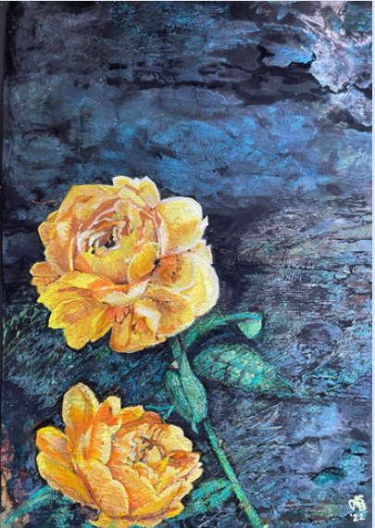

I’ve Got You

Artist – Sally A Barr

A2 16.5 x 23.4 inches

2023

London, Uk

Acrylic paint on mixed media paper

London UK

This heavily textured piece was created on 300 gsm mixed media paper. Heavy body acrylic paint layers were built up and the texture marks were defined using the dry brush technique.

A painting inspired by the support of loved ones in difficult times. Roses, particularly yellow, spark childhood memories. Knowing someone cares for and values you are strengths we can draw from.

Close up sections

